ECU — Social Media Identity Guidelines

1. Brand DNA

1.1 Product overview
ECU is a mobile app that helps everyone track their money day to day and manage it better through personalised advice. Many people don't know "where their money goes"; existing tracking apps just display figures and are rarely designed for African reality: cash, mobile money, tontine. ECU adapts to these practices while remaining usable anywhere in the world (multi-currency).

Communication positioning (proposal): ECU brings all your money — cash, mobile money, bank, tontine — together in one place and supports you, without judgement, to manage it better. This statement guides what we say; it is not meant to be published as is.

What makes ECU different — key messages:
Message | How it shows in communication
Designed for Africa | Cash, mobile money, tontine and local categories (moto-taxi, money sent to family) appear in the examples.
A real coach | Advice drawn from actual behaviour, at the right time, without being intrusive.
Suited to everyone | Simple for a beginner, rich for an advanced user.
Kind | Never a reproach: we encourage and suggest concrete ideas.
Never blocks | A balance can be negative, a due date can pass: the app flags, it doesn't forbid.
Transparent | The origin of suggestions and the estimated nature of some figures are always explained.
Fast | An expense is added in one or two taps from the home screen.

1.2 Values and brand essence
ECU's essence rests on six notions, taken from the logo sheet.
Value | Concrete translation in communication
Growth | We show real progress, even small: a savings goal reached at 25%, 50%, 75%.
Trust | No unrealistic promises; we explain what the app does and doesn't do.
Clarity | One message, simple words, no unexplained financial jargon.
Management | We give concrete methods that can be applied today.
Education | We explain so that everyone understands and decides for themselves.
Responsibility | We encourage saving and balance, never impulse spending or debt.

1.3 Brand personality
Every post, visual and video expresses four traits:
- Kind — never a reproach, never shame about money; we encourage and suggest a way forward.
- Clear — simple words, one idea, a concrete example.
- Close — locally lived situations: a moto-taxi ride, tontine, a mobile-money withdrawal, sending money to family.
- Encouraging — every small win is celebrated, without exaggeration.

ECU is not: a lecturer, a bank, an investment adviser, nor a brand that promises to make you rich.

1.4 Tone by platform (proposal)
Platforms | Register | Address
Instagram, TikTok | Warm, direct, educational, lively. | Informal "tu"
Facebook | Accessible, narrative, community-minded. | Informal "tu"
LinkedIn | Measured, well-argued, credible. | Formal "vous"

In all cases, ECU's voice is positive, simple and reassuring. One register per post: "vous" and "tu" are never mixed in the same piece of content.

2. Visual identity

REFERENCE — This section draws on ECU brand guidelines v0.1. Where they differ, the brand guidelines prevail. Shades of green, grey and state colours marked "proposed" in those guidelines are still to be approved; no colour or font may be added outside them.

2.1 Brand graphic elements
- Flat areas and rounded shapes: radii of 28 px (cards), 14 px (fields), 999 px (badges, buttons).
- Brand gradient: 45°, from #1B6B22 to #2DA333.
- Phone mock-up showing a legible screenshot of the real app.
- Google Play and App Store badges, official and unaltered, on visuals that invite a download.
- Brand-essence pictograms (growth, trust, clarity, management, education, responsibility): 2 px stroke, rounded ends, #1B6B22; never filled or multicolour.

The reference visuals used for the content strategy only illustrate the structure of the four models (chapter 4). They must not be copied: ECU's templates are original creations in ECU's colours.

2.2 Photographs, people and screenshots

- Real people, in recognisable everyday situations (street, home, workplace, phone in hand), reflecting the age diversity of the three profiles.
- Image rights: written authorisation for any identifiable person photographed or filmed by the team; commercial licence for any stock image.
- No visible third-party brand: no logo, shop sign or competing app in the visual.
- No AI-generated visual depicting people (proposal, point P6).
- Screenshots: only of the ECU app (published version or demo account), with fictional data. Amounts are in local currency (FCFA by default), with no "$" sign inherited from a foreign mock-up.

3. Content series

3.1 Role of the series
The series structure the editorial line. Each has an objective, a target, formats and one or more visual models. They let anyone joining the team know immediately what to produce, and let the audience recognise ECU content at first glance.

3.2 The eight series and their weighting (proposal)
Series | Axis | Share | Objective | Main target | Visual models
ECU au quotidien (ECU Day to Day) | Brand and community | 15% | Make people love the brand and show the benefits of better money management. | Amina, Kevin, Sarah | 1
Parlons argent (Let's Talk Money) | Brand and community | 15% | Address the financial situations users actually face. | Amina, Kevin | 2
ECU répond (ECU Answers) | Brand and community | 10% | Create a dialogue with the community and answer its questions. | The whole community | 2 and 4
L'astuce ECU (The ECU Tip) | Practical value | 15% | Deliver practical value and make people want to follow the page. | Amina, Kevin | 2 and 3
Le défi épargne (The Savings Challenge) | Practical value | 10% | Encourage users to set goals and make progress. | Amina, Kevin | 1 and 2
Découvre ECU (Discover ECU) | Product and conversion | 15% | Make the app's features known. | New users, Sarah | 3
Le problème du jour (Problem of the Day) | Product and conversion | 10% | Grab attention by starting from a concrete problem. | Amina, Kevin | 4
Passe à ECU (Switch to ECU) | Product and conversion | 10% | Turn interest into downloads and use of the app. | Interested people | 3 and 4

RULE — Over each four-week cycle, at least 60% of posts deliver value without presenting the product (ECU au quotidien, Parlons argent, ECU répond, L'astuce ECU, Le défi épargne). Passe à ECU does not exceed 10% of posts. Each visual's badge carries the exact name of the series; the proposed brand hashtag is #ECUapp.

A single series can use several visual models to vary content and avoid repetition. Example: "Le défi épargne" can show a person saving (model 1), two friends discussing their goals (model 2) or a demonstration of the savings feature (model 3).

3.3 Summary sheets by series
Full operating sheets (production specifications, caption rules, hashtags, annotated examples) are in Module 02. Sample hooks are written in the informal "tu"; they convert to the formal "vous" on LinkedIn. Hooks are French copy, with a gloss.

ECU au quotidien — Emotion and lifestyle
Item | Detail
Objective | Make people love the brand and show the benefits of better money management.
Topics | Moments of life, financial peace of mind, small everyday wins.
Formats | Square or portrait visual, short video, story.
Platforms | Instagram, TikTok, Facebook
Sample hook | "Plus de clarté sur ton argent, plus de sérénité au quotidien." (More clarity about your money, more peace of mind every day.)

Parlons argent — Real-life situations
Item | Detail
Objective | Address the financial situations users actually face.
Topics | End of the month, difficulty saving, tontine, sending money to family.
Formats | Portrait visual, carousel, short video.
Platforms | Facebook, Instagram, TikTok
Sample hook | "Où passe ton argent à la fin du mois ?" (Where does your money go at the end of the month?) · "Pourquoi est-il difficile d'épargner ?" (Why is it hard to save?)

Découvre ECU — Product presentation
Item | Detail
Objective | Make the app's features known.
Topics | Account tracking, expense entry, budgets, savings goals, calculator, privacy mode.
Formats | Visual with mock-up, feature carousel, short screen demo.
Platforms | Instagram, TikTok, Facebook, LinkedIn
Sample hook | "Une dépense ajoutée en deux taps." (An expense added in two taps.)

Le problème du jour — Problem and solution
Item | Detail
Objective | Grab attention by starting from a concrete problem, then present ECU's answer.
Topics | Spending with no budget, multiple accounts, vanishing money, forgotten due dates.
Formats | Problem / solution visual, short video.
Platforms | Instagram, TikTok, Facebook, LinkedIn
Sample hook | "Tu dépenses sans suivre ton budget ?" (Spending without following your budget?) · "Tu as plusieurs comptes et tu perds le fil ?" (Several accounts and losing track?)

Le défi épargne — Goals and progress
Item | Detail
Objective | Encourage users to set goals and make progress.
Topics | Weekly saving, goal with amount and date, milestones at 25%, 50%, 75%, 100%.
Formats | Visual, challenge carousel, story, short video.
Platforms | Instagram, TikTok, Facebook
Sample hook | "Ton prochain objectif : mettre un peu d'argent de côté chaque semaine." (Your next goal: set a little money aside every week.)

L'astuce ECU — Practical value
Item | Detail
Objective | Deliver practical value and make people want to follow the page.
Topics | Telling essentials from wants, preparing a budget, anticipating recurring expenses.
Formats | Carousel (3 to 7 slides), visual, short video.
Platforms | Instagram, TikTok, Facebook, LinkedIn
Sample hook | "Essentiel ou envie ? Une astuce pour trancher." (Essential or want? A tip to decide.)

ECU répond — Dialogue with the community
Item | Detail
Objective | Create a dialogue with the community and answer its questions.
Topics | Questions received in comments or messages, made anonymous.
Formats | Question / answer visual, short video.
Platforms | Instagram, TikTok, Facebook
Sample hook | "Comment suivre son argent lorsqu'on utilise à la fois du cash et du mobile money ?" (How do you track your money when you use both cash and mobile money?)

Passe à ECU — Call to download
Item | Detail
Objective | Turn interest into downloads and use of the app.
Topics | First steps (first use in under two minutes), key benefits, invitation to try.
Formats | Visual with Google Play and App Store badges, short screen demo.
Platforms | Instagram, TikTok, Facebook, LinkedIn
Sample hook | "Prêt à mieux gérer ton argent ? Découvre ECU." (Ready to manage your money better? Discover ECU.)

3.4 The four visual models
The visual models are the creation base: they apply to every series, ensuring consistency while varying content.

Model | Principle | Compatible series
Model 1 — A relaxed person | A person at ease, serene, in a life situation, with their phone. | ECU au quotidien, Le défi épargne
Model 2 — People together | Two or more people talking, comparing, advising each other. | Parlons argent, ECU répond, Le défi épargne, L'astuce ECU
Model 3 — The phone and the app | A phone in focus with a legible ECU screenshot. | Découvre ECU, L'astuce ECU, Passe à ECU
Model 4 — A problem and its solution | A problem situation on one side, ECU's answer on the other. | Le problème du jour, ECU répond, Passe à ECU

3.5 Recurring formats
No recurring format (series) is defined in this edition. When one is created, it will be attached to just one of the eight content series, whose badge and hashtags it reuses. The series name complements the badge; it never replaces it.

4. Writing rules

4.1 Writing principles
- Start from the lived situation: never from the feature or the product name.
- Write to be understood: simple words, no unexplained financial jargon.
- Get to the point: the first lines carry the message.
- Encourage, never reproach: no guilt about spending or saving.
- End with an invitation: every post ends with a single, explicit call to action.

4.2 Brand, language and register
- Brand spelling: "ECU" in capitals in all texts, never "Ecu" or "E.C.U.". Proposed brand hashtag: #ECUapp. The logo keeps its design.
- Language: French. All visual elements are in French ("Glissez", "Fin"). Everyday terms are accepted: mobile money, cash, tontine, budget, application.
- Register: informal "tu" on Instagram, TikTok and Facebook; formal "vous" on LinkedIn; one register per post.
- Formatting: no Unicode "bold" or "italic" characters in captions; emoji in limited numbers, per Module 02.

4.3 Vocabulary
Prefer | Avoid
Track, see clearly, set aside, goal, step, landmark | Reproaches: "you spend too much", "you manage badly"
"You can", "we suggest", "an idea" | Promises: "get rich", "zero debt", "guaranteed result"
Concrete example, amount in FCFA, local situation | Unexplained financial jargon, artificial urgency ("last chance")

4.4 Good practice
- Anchor every piece of content in a recognisable local situation.
- Include a concrete example; any example amount is fictional, labelled as such and expressed in local currency.
- Give a single explicit call to action.
- Have every piece of content proofread for spelling, factual accuracy and accuracy of the product message.
- Reply to comments in the brand's spirit: kind, simple, without judgement.

4.5 Forbidden content
- Investment advice, promises of returns or gains, guaranteed financial results.
- Guilt-tripping, mockery or pressure to spend or borrow.
- Comparing or disparaging banks, operators or competing apps.
- Logos of mobile-money operators or banks, or any wording suggesting a partnership.
- Presenting ECU as a bank, a payment service or an investment adviser.
- Features not available in the published version.
- Religious or political content; generic motivational slogans.
- AI-generated visuals depicting people; visible third-party brands.
- Unverified or invented download, user, review or result figures.
- Testimonials, photos or user data without written consent; screenshots containing real personal data.
- Casual hashtags or brand slang.

4.6 Accuracy of the product message
Only features of the published version are presented; the product manager confirms the list before each campaign. The first version's limits are never contradicted:
First-version reality | Wording to respect
No connection to mobile-money operators | Users enter their own transactions; never mention automatic synchronisation.
No automatic exchange rate | Totals in mixed currencies are indicative.
No automatic estimate of asset value | Users update the value themselves.
Simplified loan calculations | The schedule is presented as an estimate.
Advice based on defined rules | Do not announce predictive analysis or "predictions".
Home-screen personalisation planned for later | Do not present it as available.

5. Visual examples

5.1 Visual 1


5.2 Visual 2


5.3 Visual 3
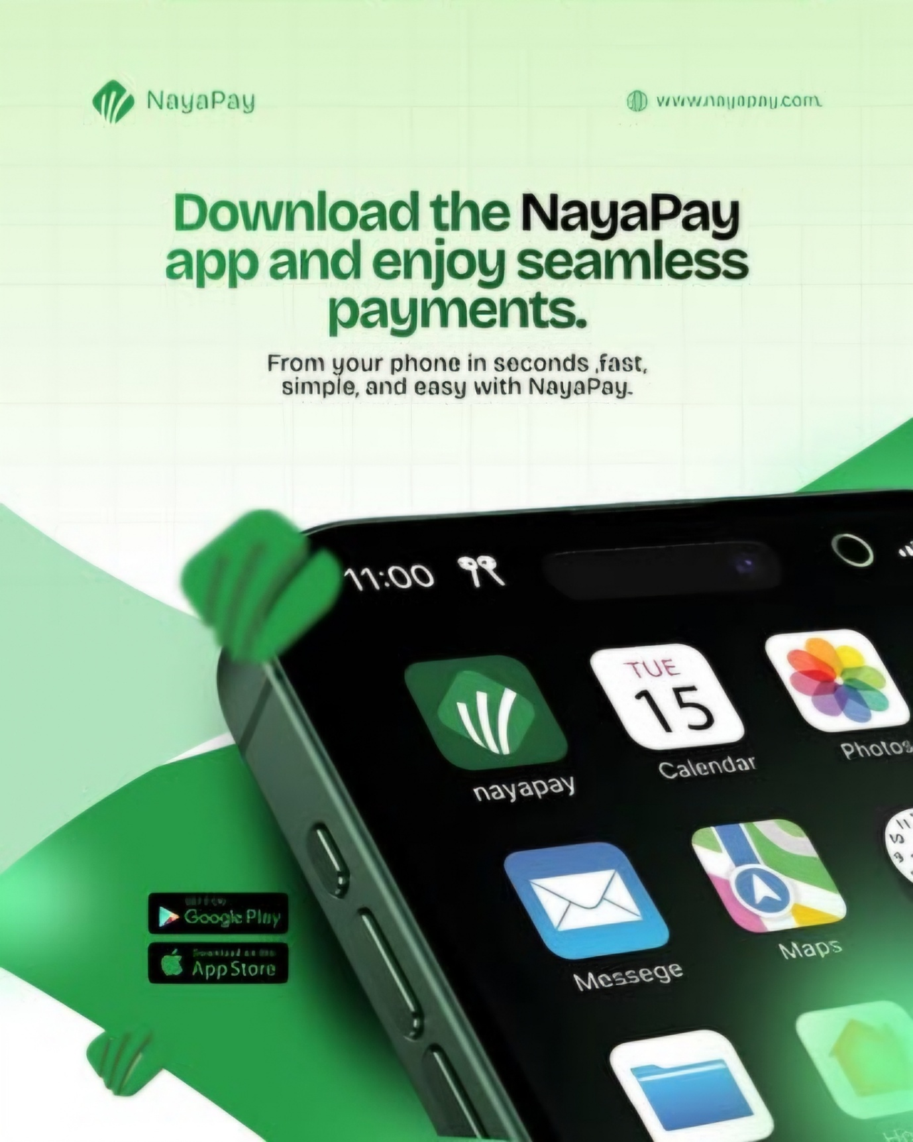

5.4 Visual 4
